Permission sets

Before giving permission sets

After giving permissions:

After permission sets NEW EDIT option available

Support people also will have access to access application

How Many days support guys can access

To force log out disable

If records created by super admin and if it is visible in another user then sharing settings is used

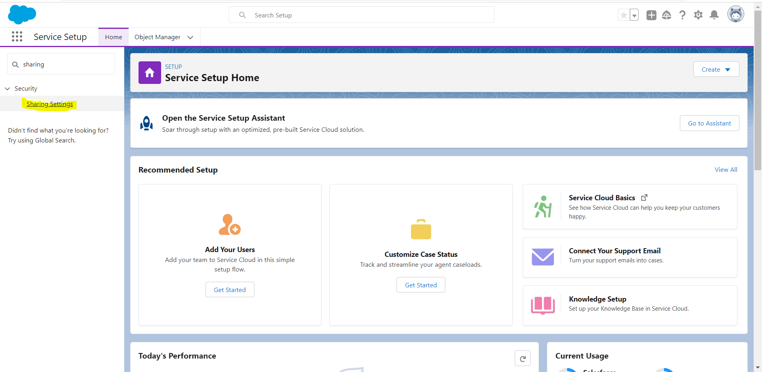

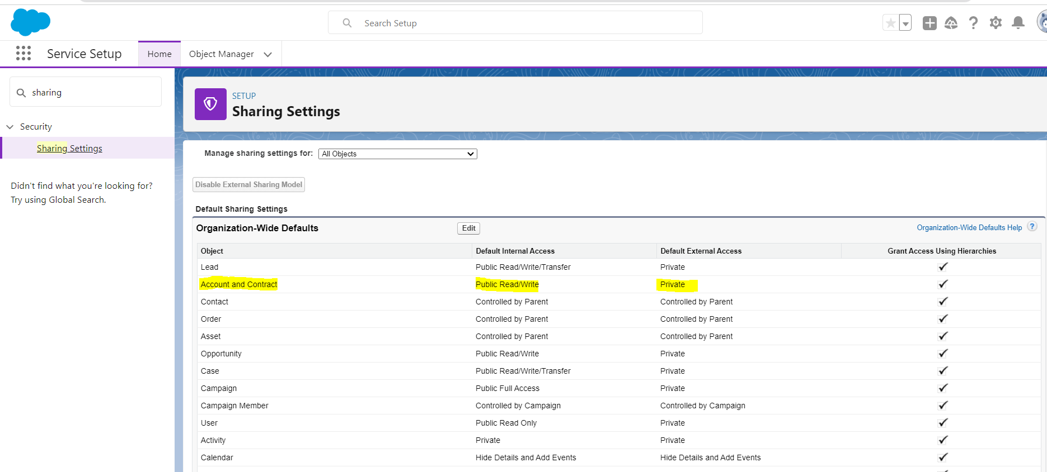

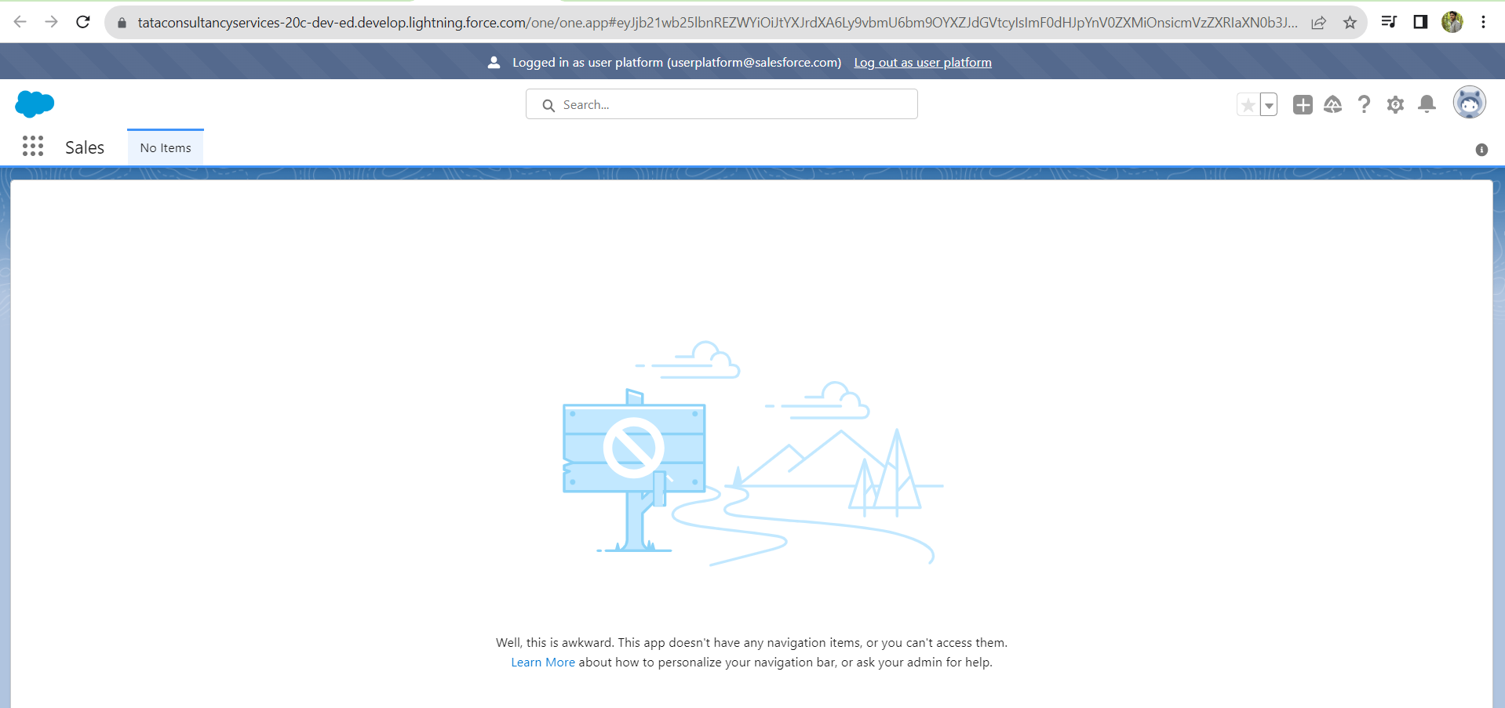

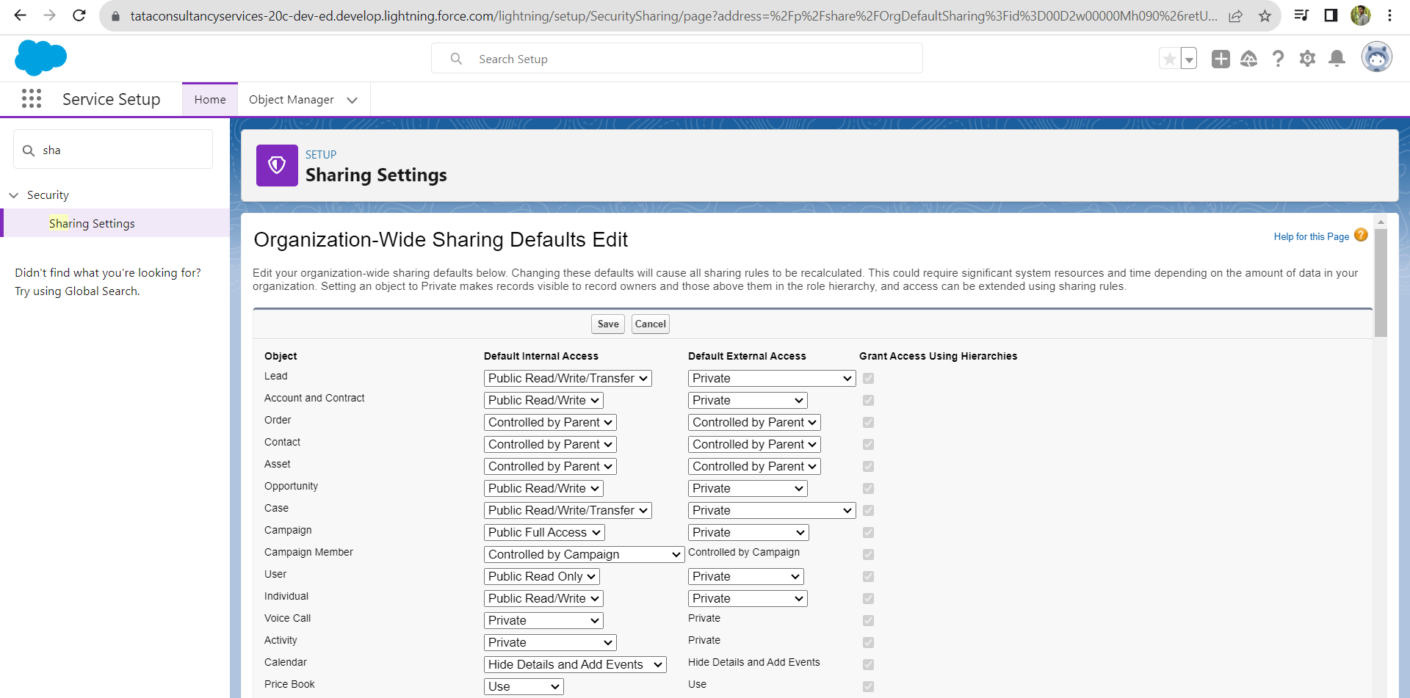

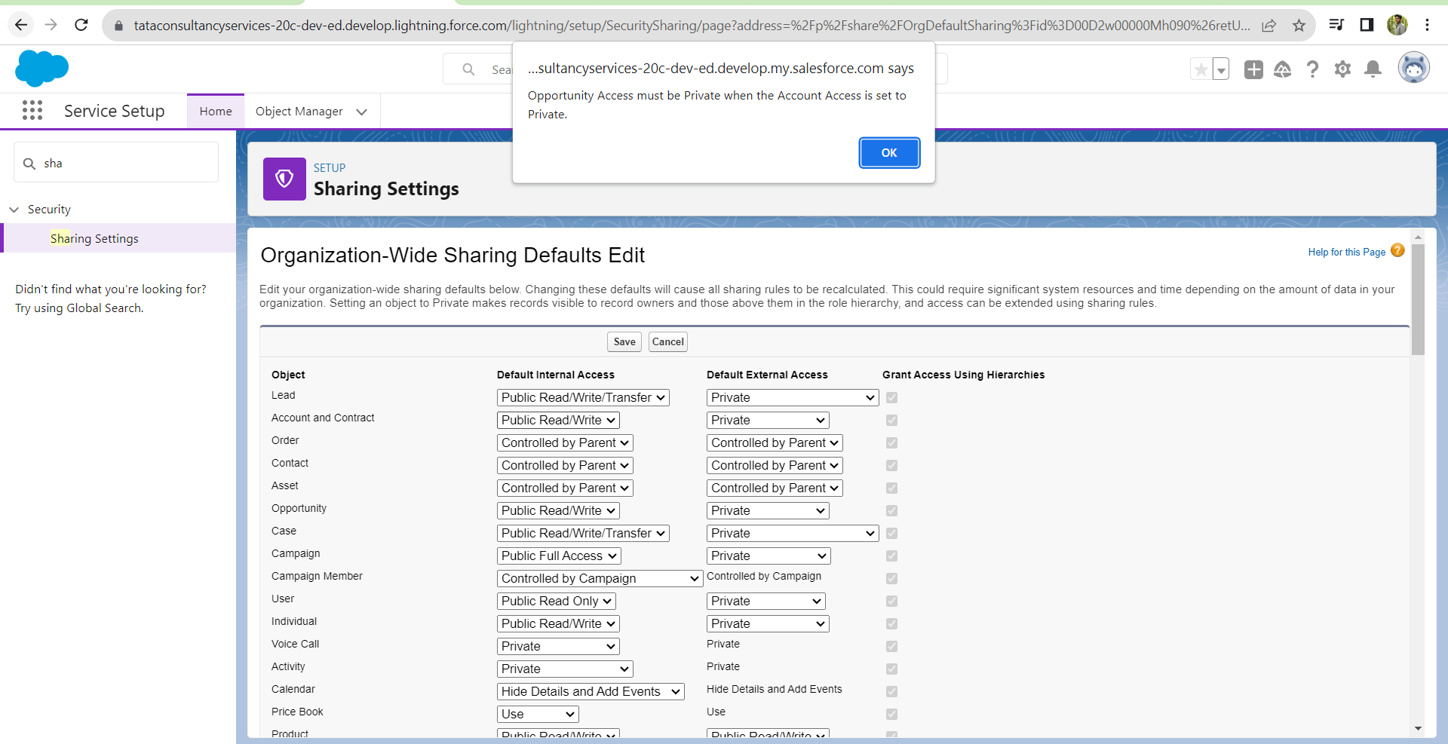

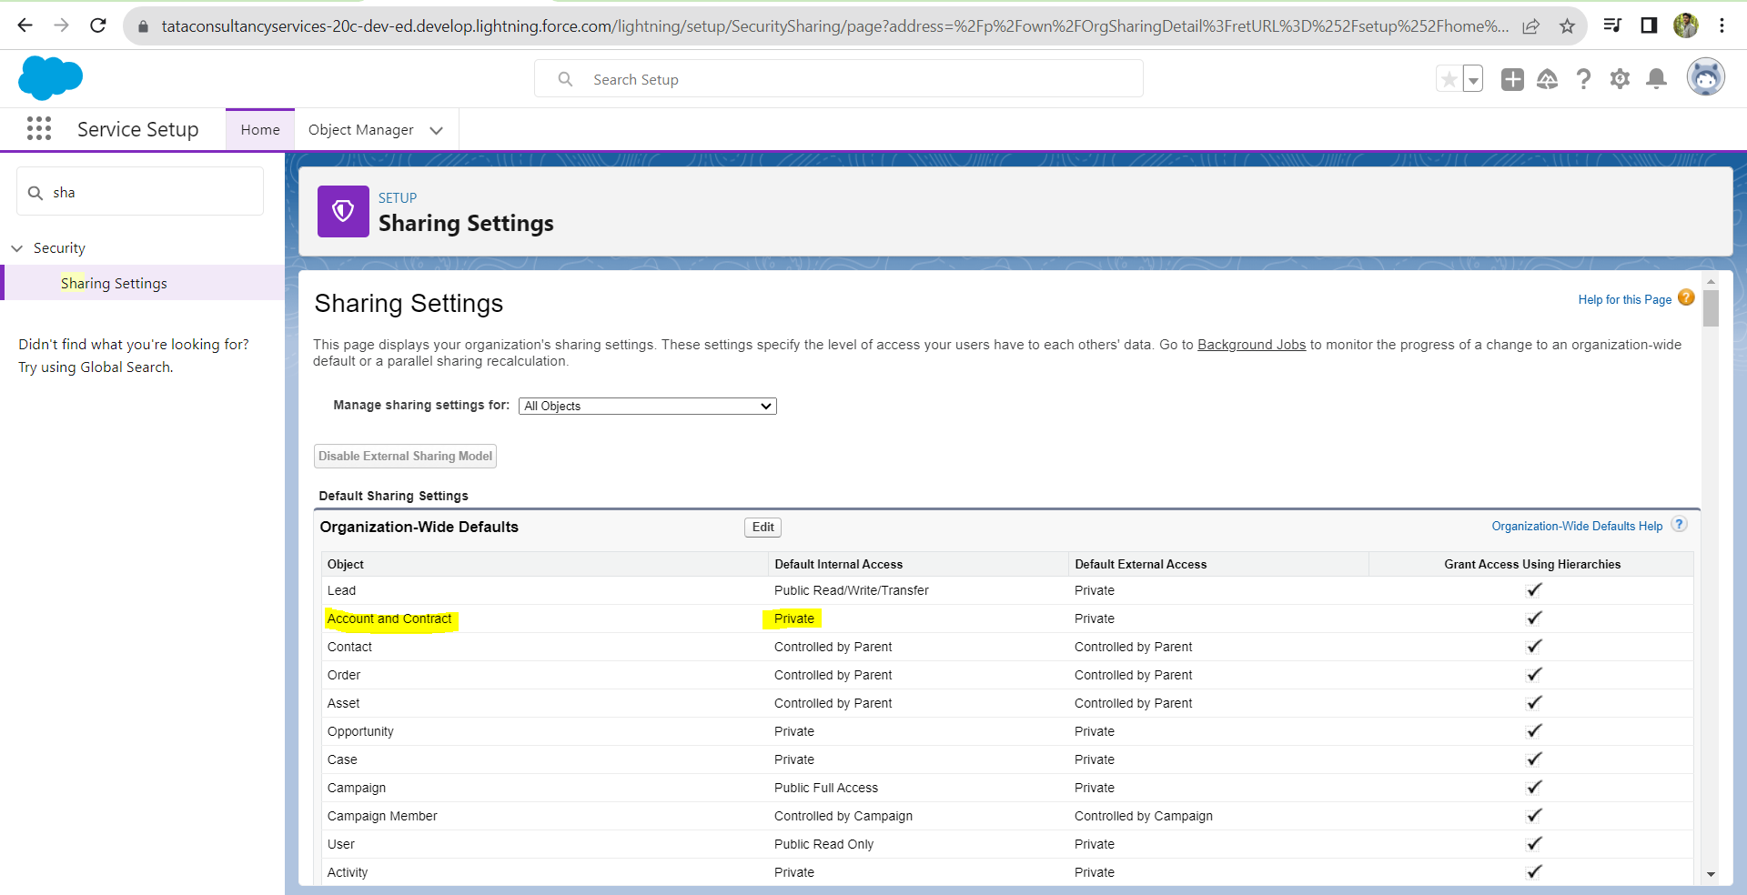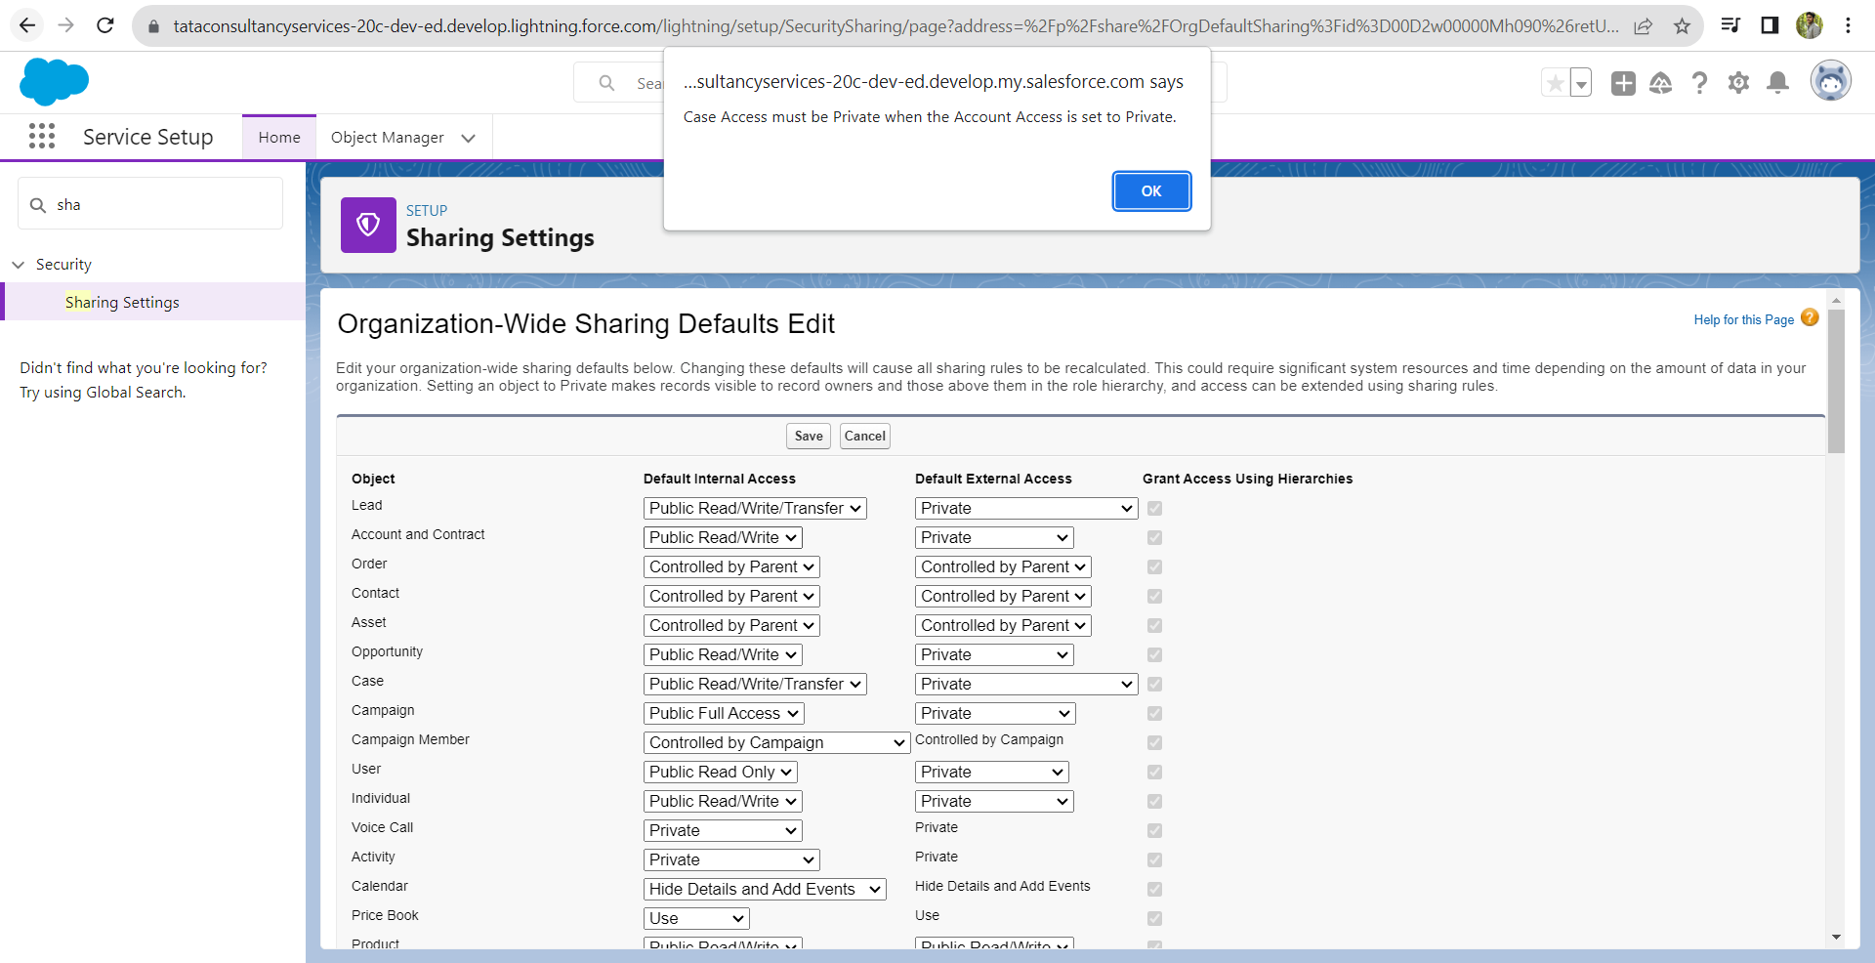

ROLES

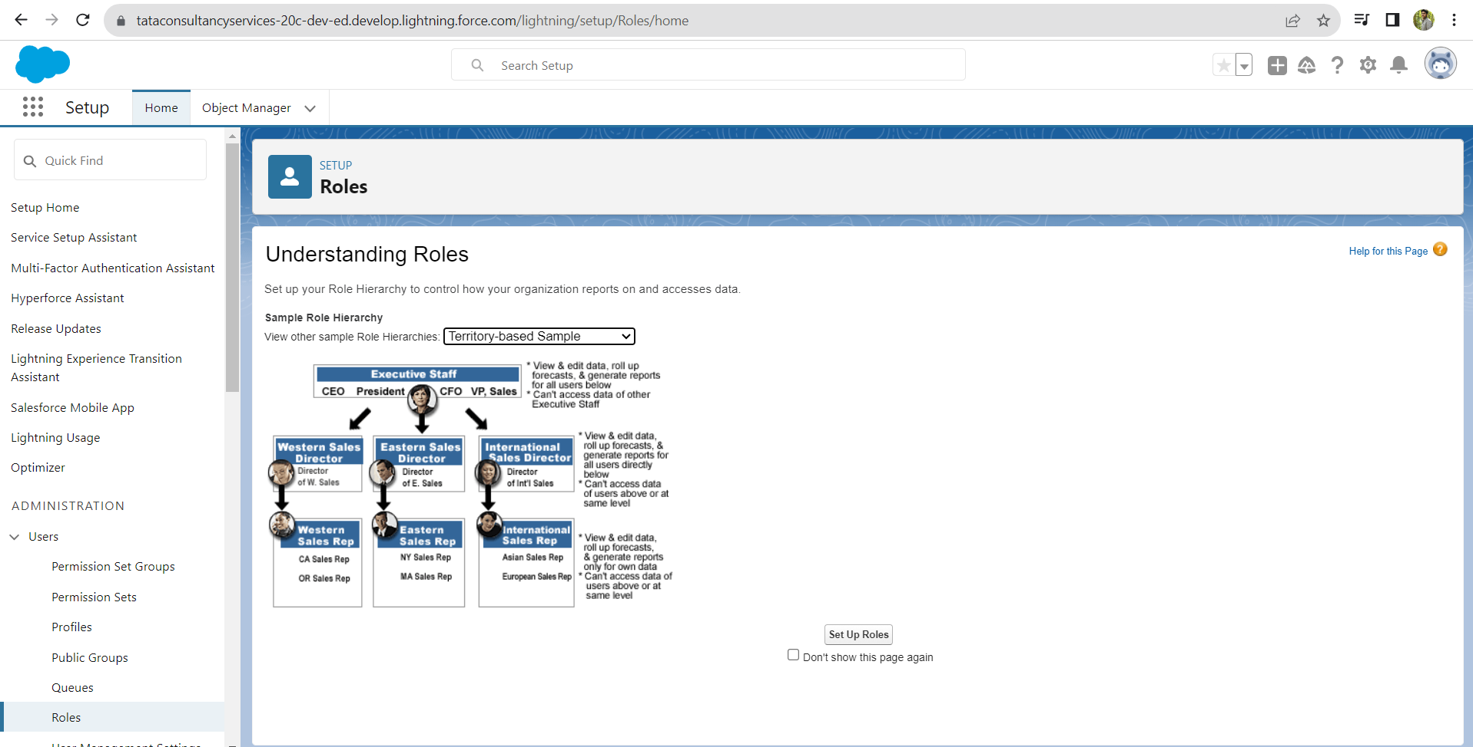

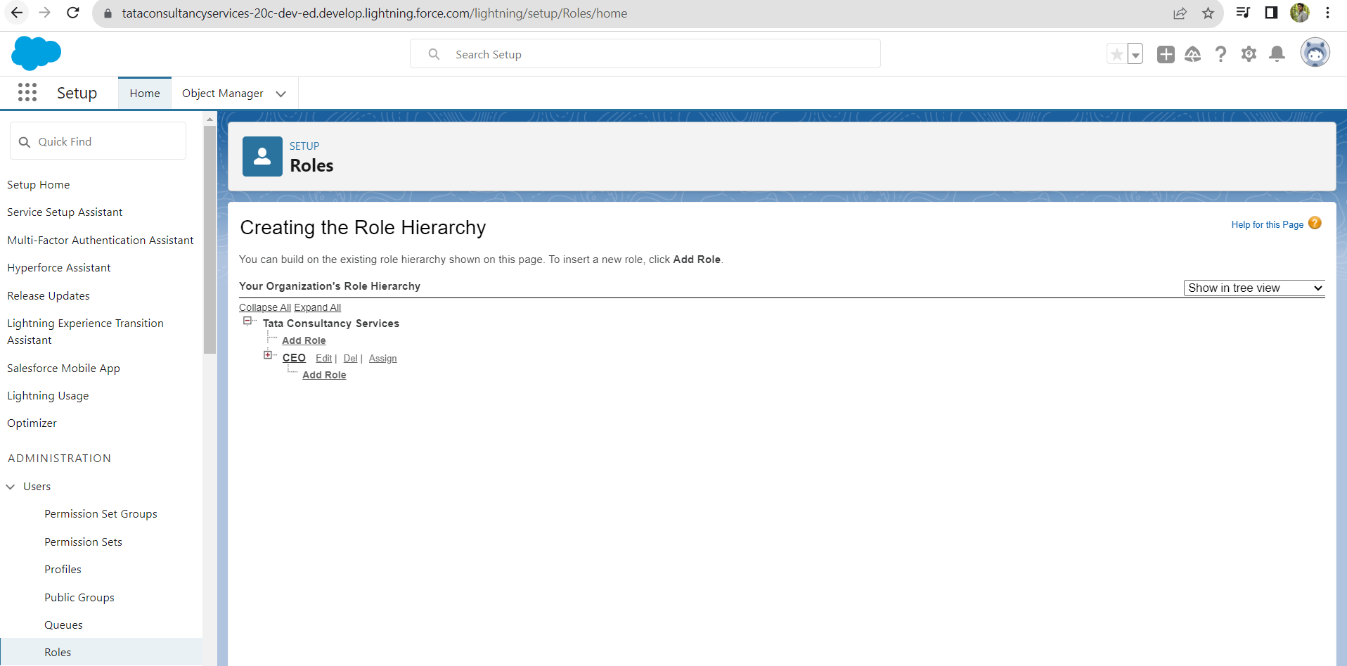

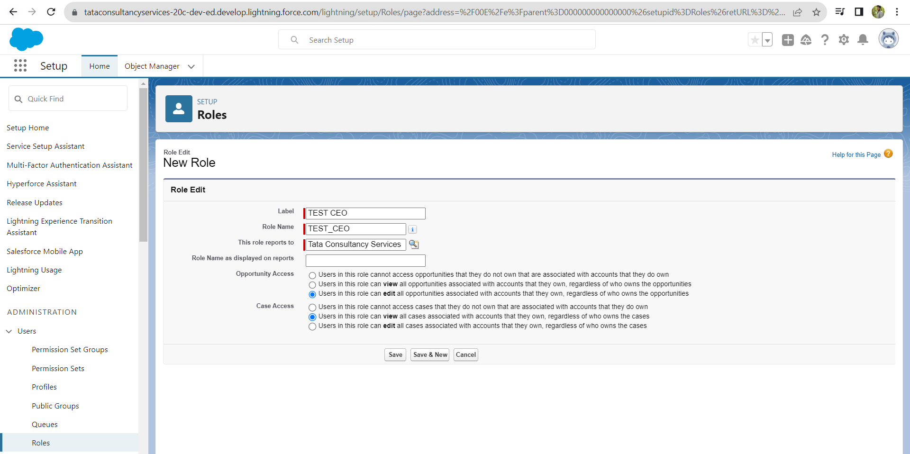

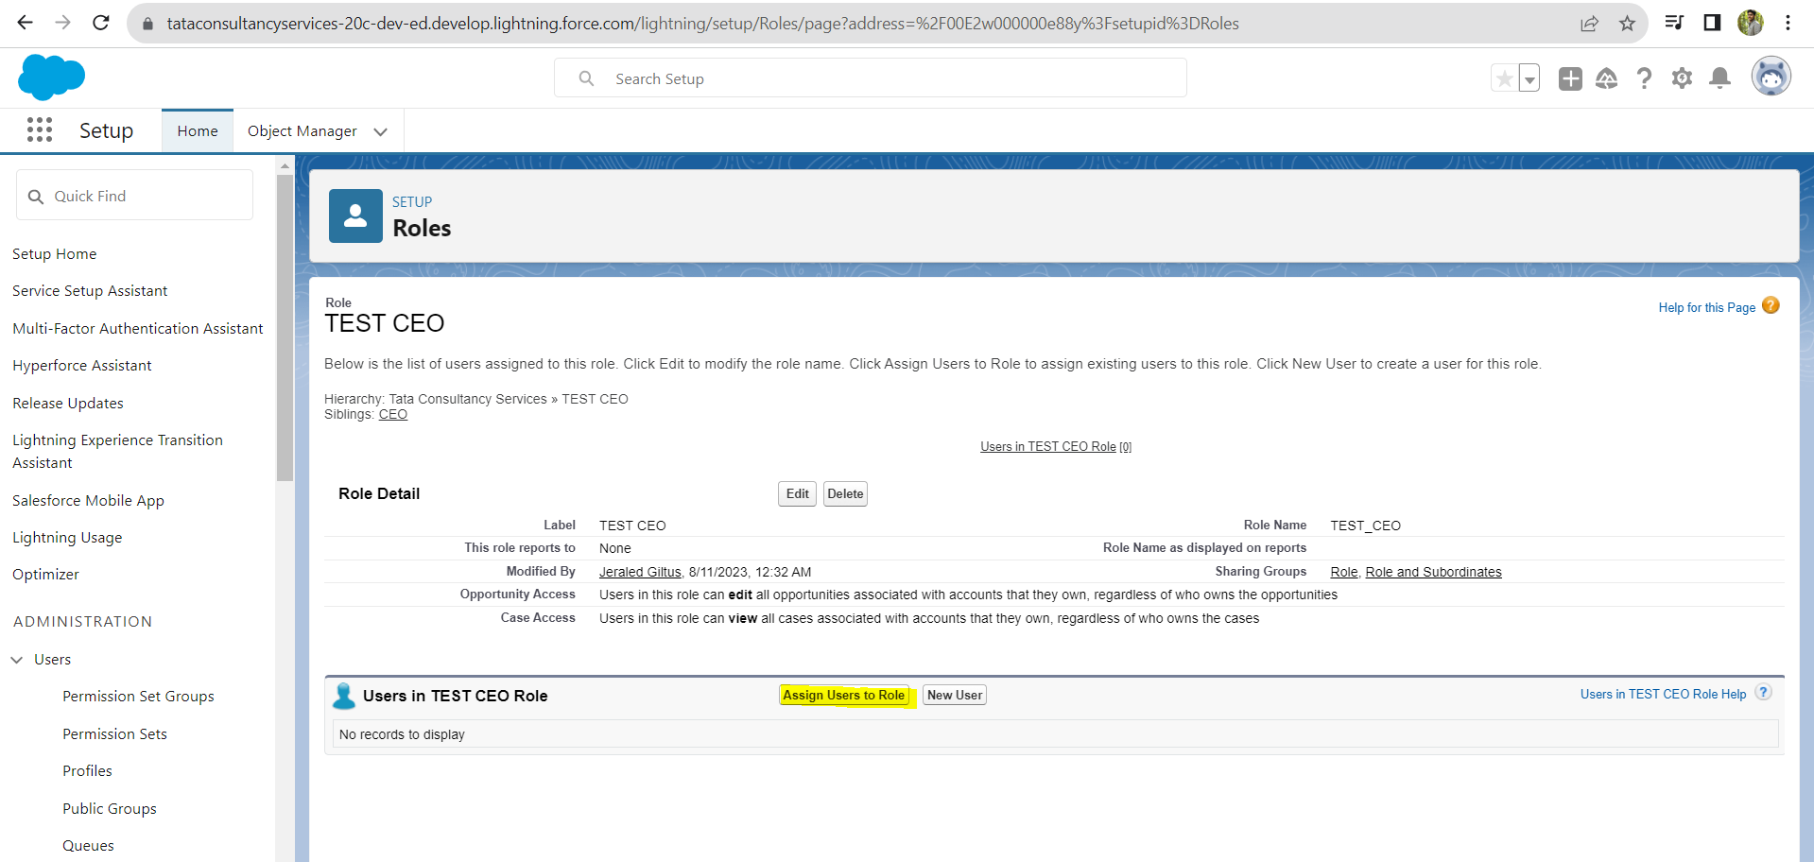

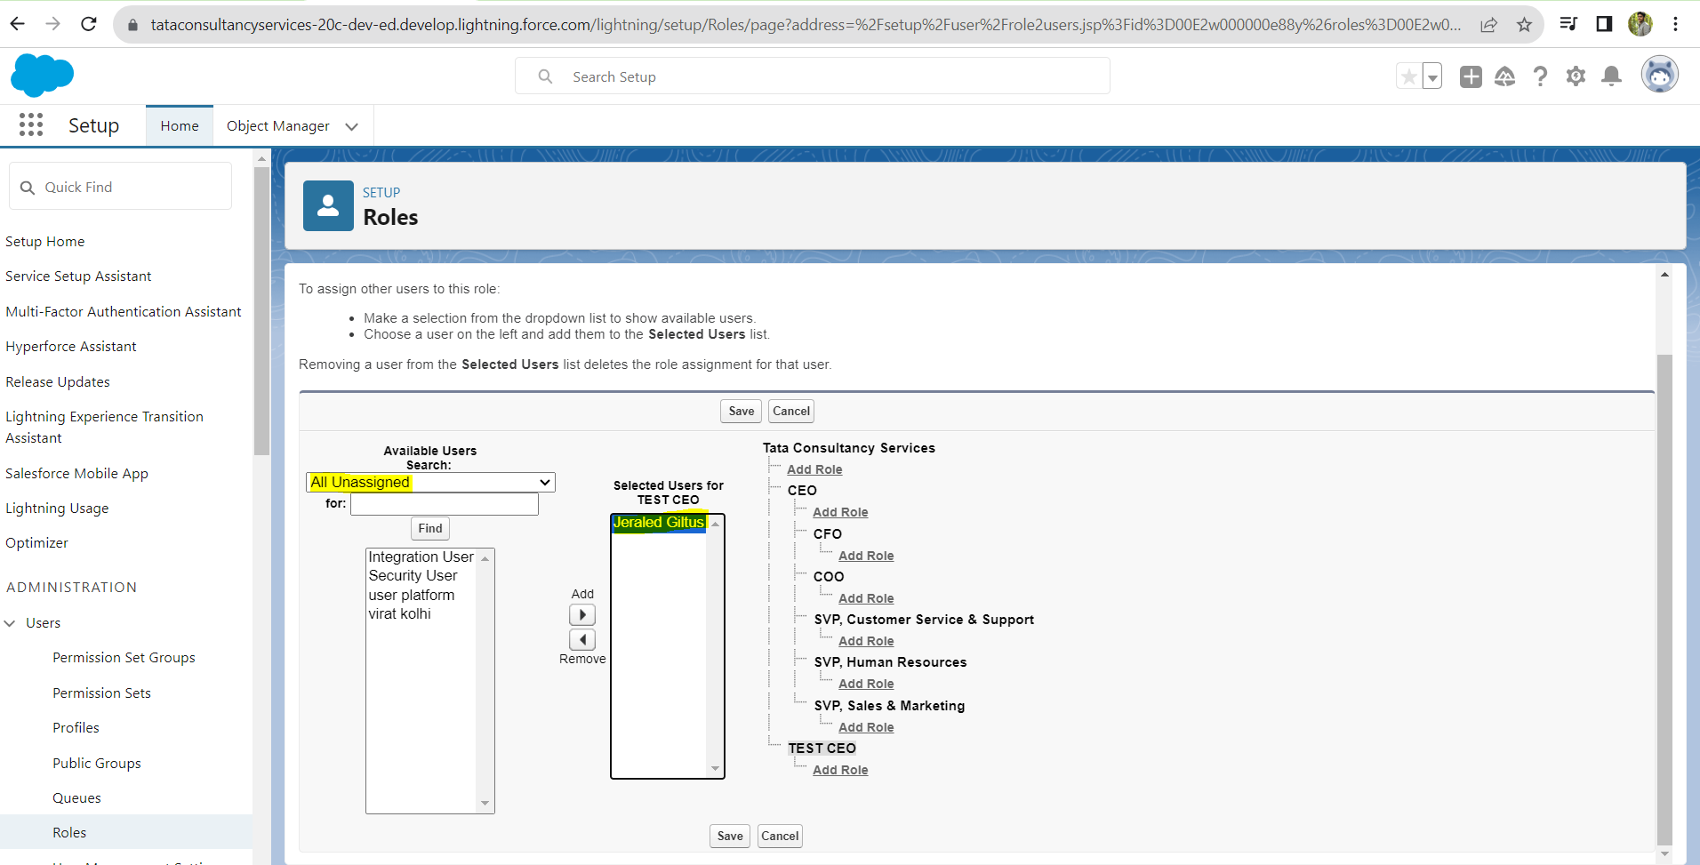

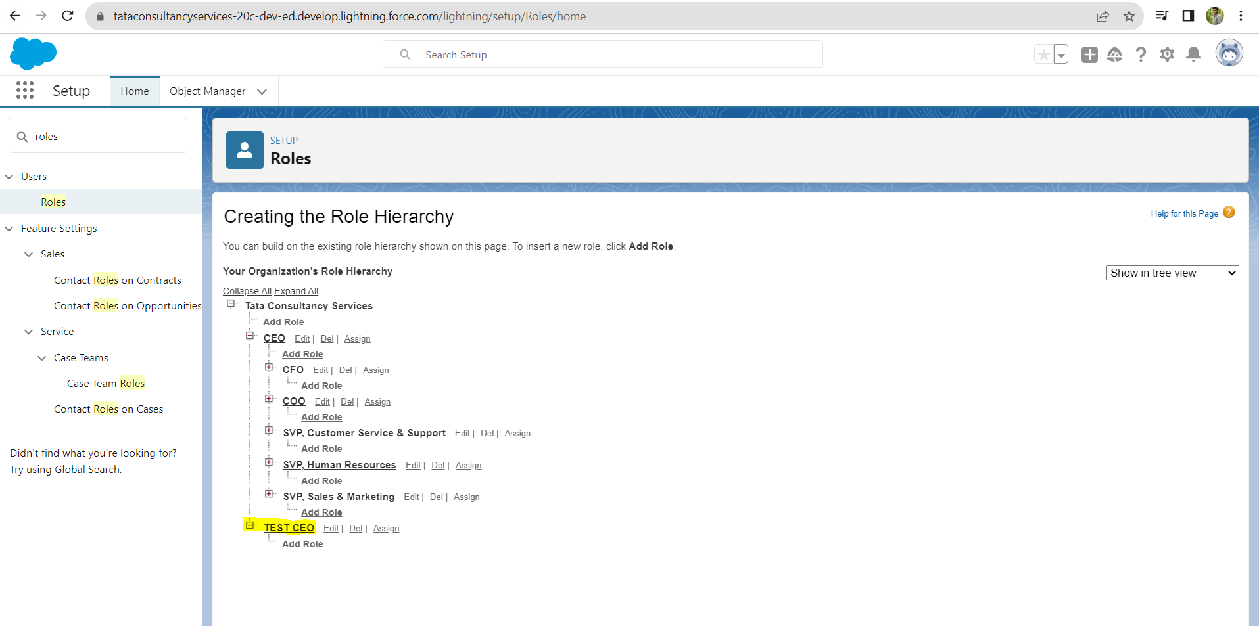

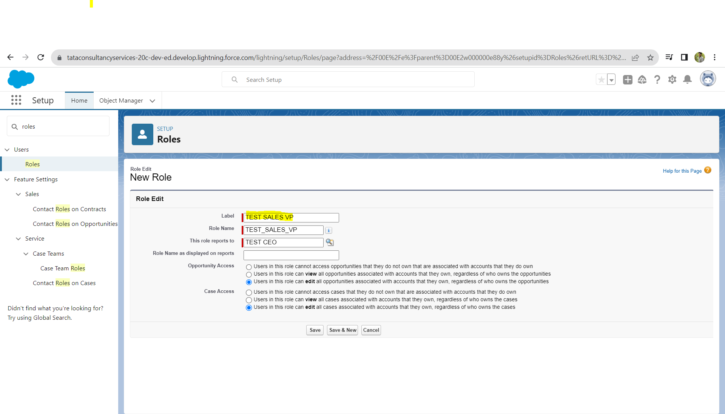

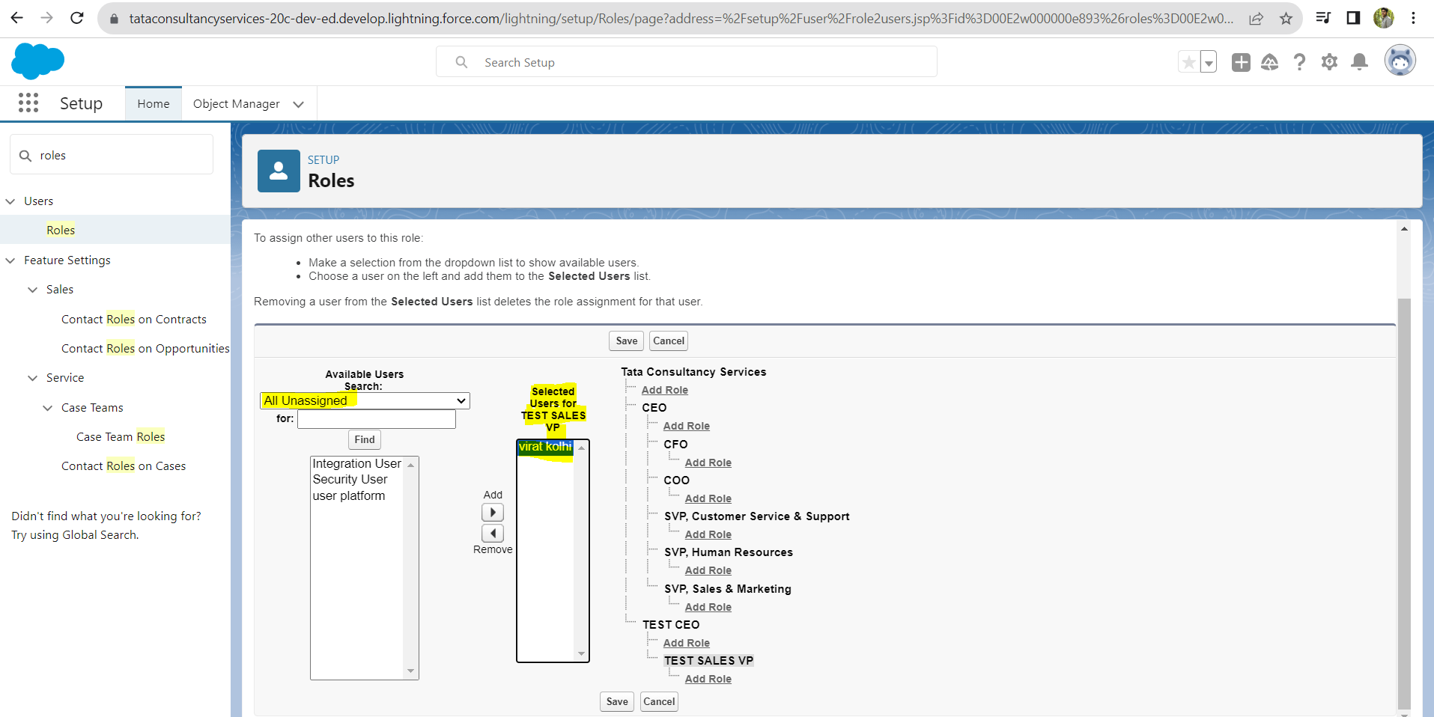

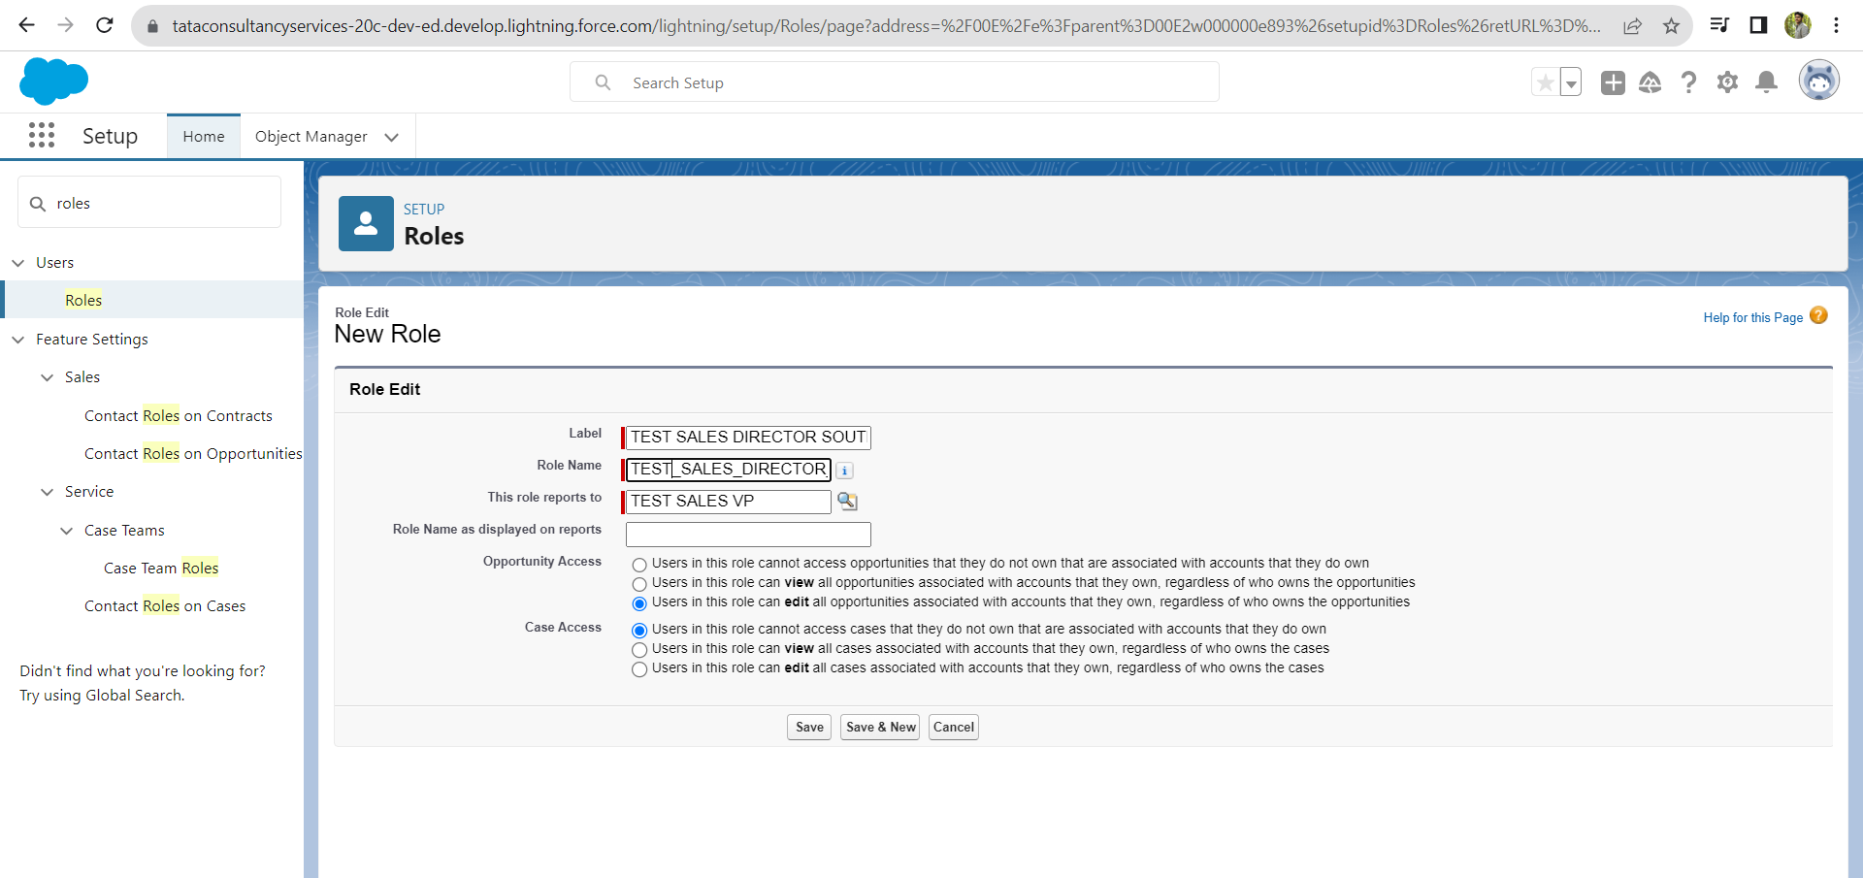

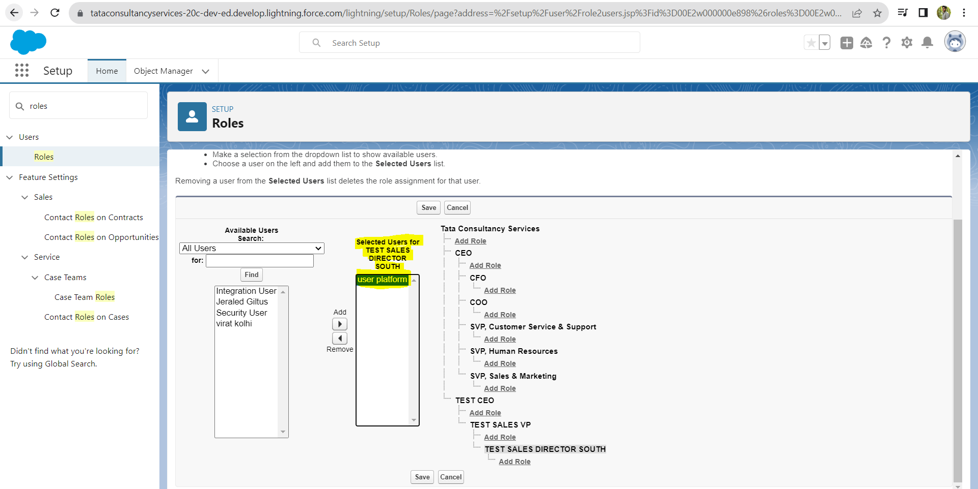

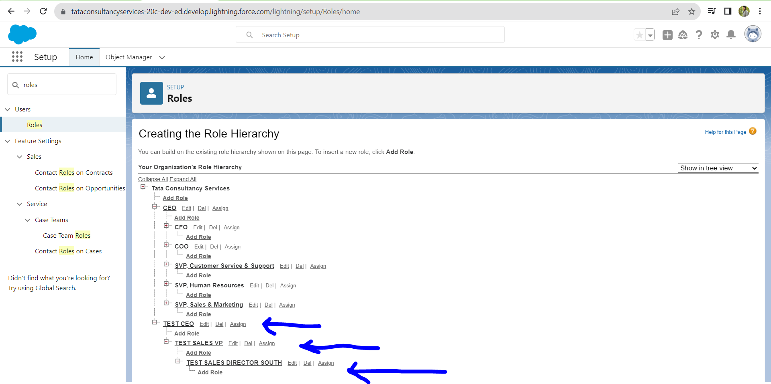

Sharing settings – customer direct type access

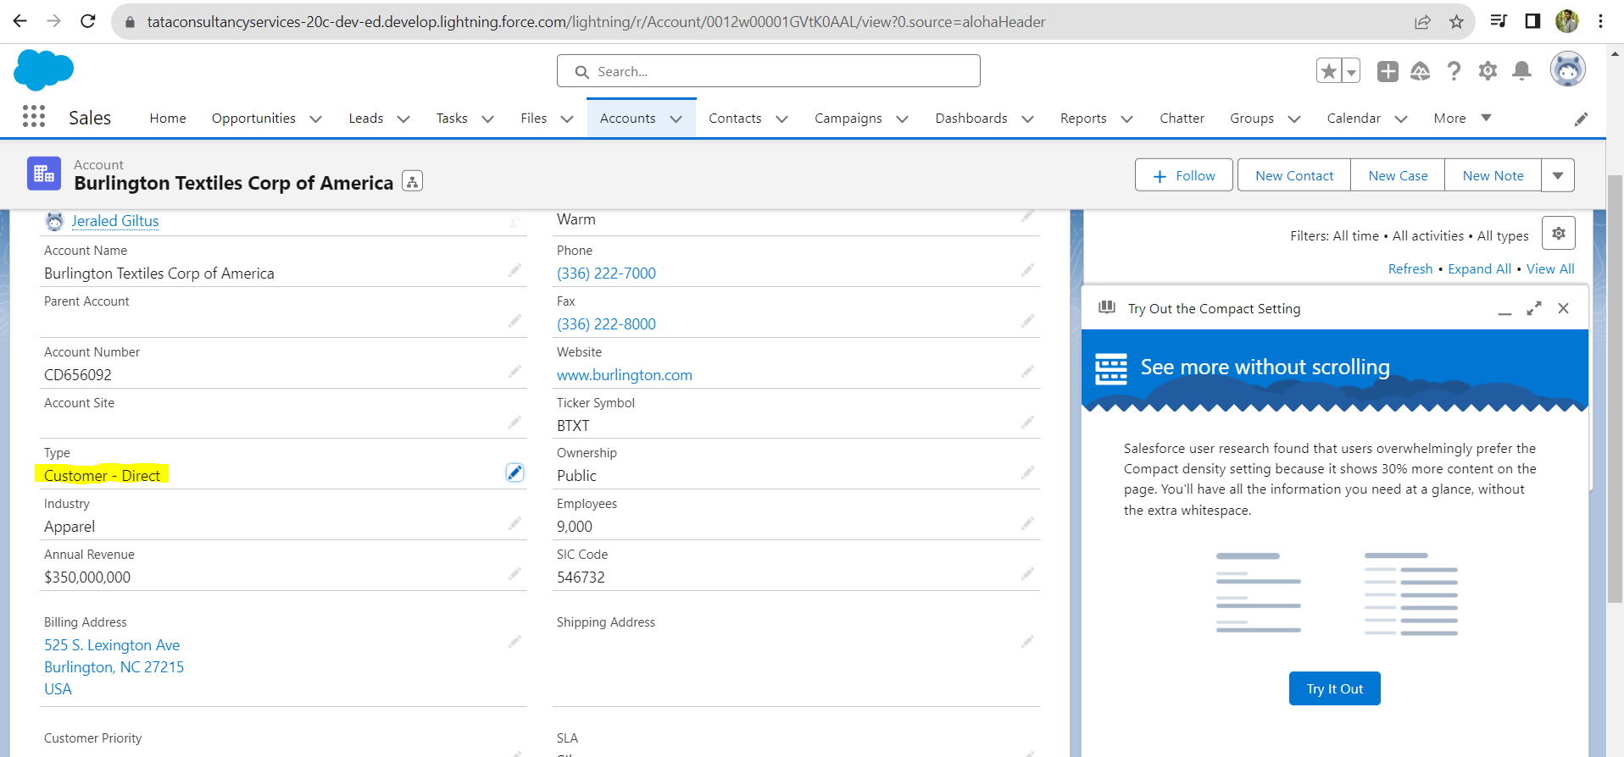

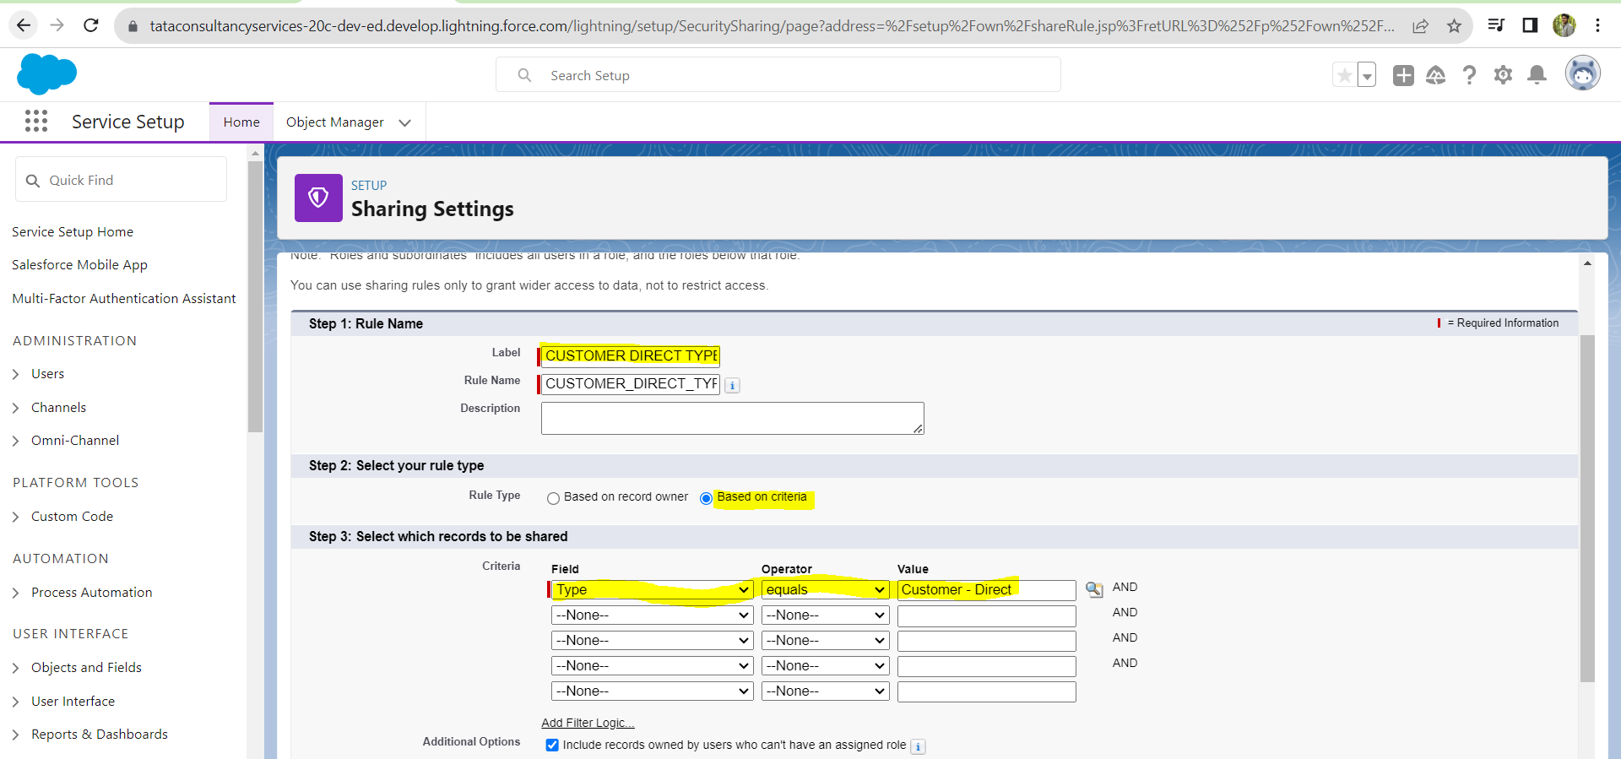

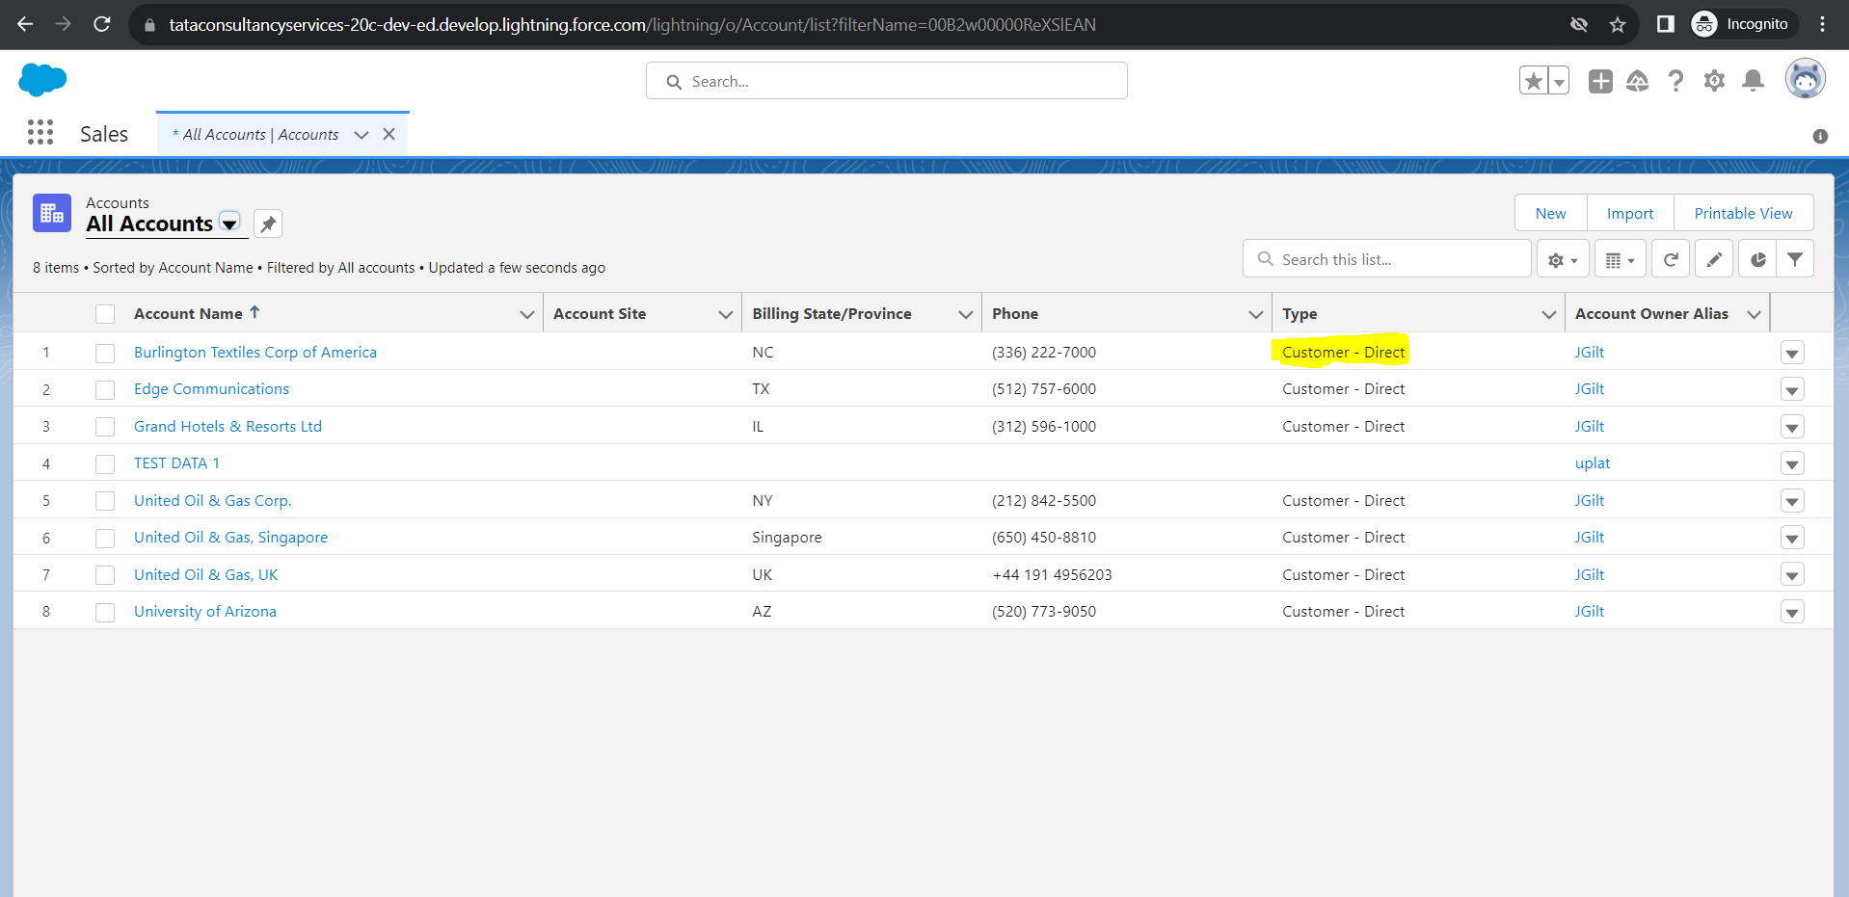

There is a concept called freeze of user means the user will freezed but their activities will remains continuing in Background

Virat -> Edit -> active flag(Uncheck)